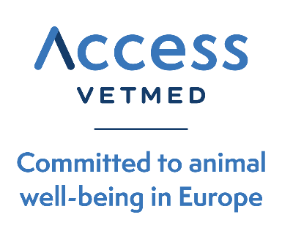

19^{h} September 2025

Contact:
silvia.humera@accessvetmed.eu
Tel. + 34 606848551

During its 23rd Annual General Managers’ Meeting

Access VetMed gathers almost 70 industry leaders in Barcelona and prepares a better regulation Action Plan

Barcelona, 19th September 2025 – Access VetMed, the voice of veterinary generics and added-value medicines in Europe, held its 23rd Annual General Managers’ Meeting on 18–19 September in Barcelona, Spain. Hosted by Alivira at the Dolce Barcelona Resort, the event brought together almost 70 CEOs and senior executives representing the association’s member companies.
The European veterinary generics industry is currently preparing a package of urgent measures to address the impact of the current regulatory framework in the European veterinary generic industry. In this regard, Regulation (EU) 2019/6, while intended to streamline procedures and enhance medicine availability, has in some cases led to increased costs and reduced operational flexibility —particularly affecting small and medium-sized enterprises (SMEs).

LINK TO PICTURE GALLERY

During the event, Access VetMed welcomed three new members –Axience, Salfarm and Emdoka –bringing its total membership to 30 companies. These members now represent over 52% of all veterinary generic registrations in Europe.

“This annual meeting is a unique opportunity for the exchange of ideas and experiences, and to address the pressing challenges faced by our sector,” said Xavier Molins, Head of Regulatory Affairs (EU) at Bimeda Animal Health Limited and Chair of Access VetMed.
“With the addition of three new members, Access VetMed grows stronger, further consolidating its position as the reference voice of the European veterinary generics and added-value medicines industry.”

One of the highlights of the meeting was the presentation of a draft Manifesto, introduced by Xavier Molins. The document, to be published in October, will call for concrete actions to mitigate the effects of the current regulatory framework that conflicts with its fundamental intent and ensures the long-term viability of the sector across the EU.

Andreas Asamer, CEO of VetViva Richter and Board Member of Access VetMed, presented recent data showing the increasing regulatory and financial burdens on the industry. He emphasized how rising administrative costs and fees are especially challenging for SMEs, limiting their ability to invest in R&D, and staff expansion for tasks that do not add value.

“Rather than achieving its original objectives, Regulation 2019/6, in some instances, increased costs and reduced flexibility for companies. Ensuring a balanced and harmonized regulatory framework is key to safeguarding access to veterinary medicines across Europe.” said Asamer.

The meeting also provided a platform to review the association’s ongoing initiatives in communication, regulatory engagement, and industry collaboration. Participants reiterated the importance of continued dialogue with EU institutions, regulators, and stakeholders to ensure that generics and added-value medicines remain integral to European animal health, food security, and sustainability.

About Access VetMed
Founded in 2002 as the European Group for Generic Veterinary Products (EGGVP), Access VetMed represents the voice of the generic and added-value veterinary medicines industry in Europe. Today, we represent 30 member companies operating across various European countries, including smaller markets. Collectively, our members account for over €2,6 billion in turnover and support more than 8.800 direct jobs. The group holds more than 52% of all generic and added-value veterinary marketing authorizations in Europe. Access VetMed advocates for a transparent, harmonized, pragmatic, and balanced animal health regulatory framework, with the aim of improving ACCESS – availability, compliance, convenience, efficacy, safety, and savings – of veterinary medicines for veterinarians, farmers, and companion animal owners across Europe.
More information: www.accessvetmed.eu

# # #

