*6th February 2025*

Contact:

[silvia.humera@accessvetmed.eu](mailto:silvia.humera@accessvetmed.eu)

Tel. + 34 606848551

**The only official study on generic veterinary medicines in Europe**

**Access VetMed launches its 2024 European Study on Generic and Value-Added Veterinary Medicines**

* Generic veterinary medicines represent **50% of all veterinary authorizations in Europe, with 60% of European Marketing Authorization Holders (MAHs) now holding generic licenses**.
* **Access VetMed members lead the way, accounting for 52% of all veterinary generic authorizations** and establishing the association as a driving force in this dynamic sector.

[**2024 Study Market Play Book.**](https://indd.adobe.com/view/f54e299c-ccb1-4d38-87d6-89807fdfc117)

**February 2025** – Access VetMed, the voice of Europe’s generic veterinary medicines industry, proudly announces the release of its comprehensive **2024 European Market Study on Generic and Value-Added Veterinary Medicines**. This third edition, spanning over two decades of data and regulatory analysis, underscores the critical role and growth trajectory of generic medicines in Europe’s veterinary sector.

“The 2024 study marks a significant advancement in our efforts to understand the veterinary generics market in Europe,” said **Xavier Molins, President of Access VetMed**. “While previous studies relied on some assumptions based on the ‘best available knowledge,’ this edition stands out for its reliance on quantitative data sourced from official channels and direct surveys to the association companies’ members. However, it’s important to note that sections on the economic importance of the animal health sector and the affordability of generic products, included in earlier studies, have been omitted this year. This may limit direct comparisons with previous editions.”

The study reveals that generic veterinary medicines represent **50% of all veterinary authorizations in Europe, with 60% of European Marketing Authorization Holders (MAHs) now holding generic licenses**. Among these, Access VetMed members lead the way, **accounting for 52% of all veterinary generic authorizations** and establishing the association as a driving force in this dynamic sector.

Key findings include:

* **Market leadership**: Access VetMed members hold a commanding 64% of generic authorizations for companies with more than 500 products, demonstrating their pivotal role in expanding market availability and accessibility.
* **Species and therapeutic areas**: Generics dominate authorizations for companion animals such as dogs and cats, while products for ruminants also show significant strength. Anti-infectives and antiparasitics emerged as the largest therapeutic categories, accounting for 57% of all generic authorizations.
* **Growth trends**: Enteral and local routes of administration have experienced the fastest growth in recent years, signaling innovation in product formats and accessibility.
* **Regulatory challenges**: While Regulation (EU) 2019/6 has improved harmonization, it has also introduced notable financial and administrative burdens, particularly for small and medium-sized enterprises (SMEs).

“The data confirms that the generic veterinary medicines industry in Europe remains robust and poised for continued growth, despite emerging challenges,” conclude **Xavier Molins, President of Access VetMed**. “This study provides crucial insights for the sector, from identifying new market opportunities in niche areas to highlighting areas where regulatory improvements could unlock further potential.”

Looking forward, the study emphasizes the need for addressing administrative inefficiencies and rising costs, particularly through enhanced collaboration with the European Medicines Agency (EMA) and national authorities. Such measures are critical to ensuring sustainable growth, especially for SMEs navigating complex regulatory landscapes.

**Learn more about veterinary generics**

Generic veterinary medicines emanate from the same molecule as the originator. **They are equally high quality, safe and efficient as the originators**. Generics are thoroughly assessed, authorised and regulated by the competent authorities before entering the market. They need to comply with the stringent quality, safety and efficacy requirements for the animal, human health and the environment. To operate in Europe, the generic producers also have to follow rigorous manufacturing standards and quality controls known as good manufacturing practice (GMP).

Generic medicines are authorised and placed on the market after intellectual property and other protection periods associated to the originator product have expired. This may take up to 25 years. When entering the market, generics will be produced with up-to-date technology, enhanced analytical capacities and materials complying with the most recent regulations.

**[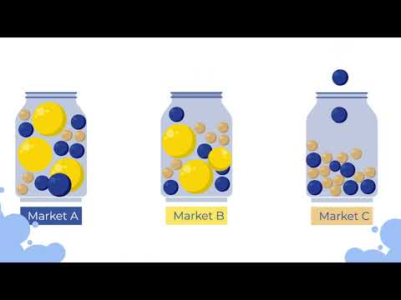](https://www.youtube.com/embed/TKXIQel1zx0?feature=oembed)**

**About Access VetMed**

Access VetMed was founded in 2002 as the European Group for Generic Veterinary Products (EGGVP) to serve as the voice of the generic veterinary medicines industry in Europe. Today, we represent **27 generic and added-value veterinary medicines companies** located in various European countries, including smaller markets. Together, our members have **a turnover of over 2,4 billion euros** and support **more than 8.600 direct jobs**, **holding 52% of all generic veterinary medicines marketing authorizations** in Europe.

We actively and constructively engage with EU regulators and other stakeholders to advocate for transparent, harmonized, pragmatic and balanced animal health regulation. Our primary objective is to increase ACCESS – availability, compliance, convenience, efficacy, safety, and savings – of veterinary medicines to veterinarians, farm, and companion animal owners in Europe.

More information: [www.accessvetmed.eu](http://www.accessvetmed.eu)

**# # #**