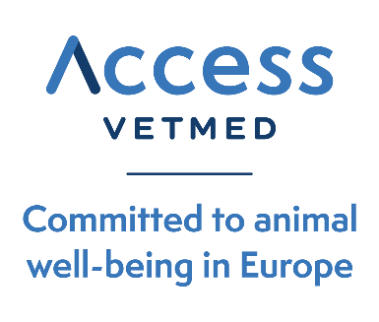

9th April 2026

Contact:
silvia.humera@accessvetmed.eu
Tel. + 34 606848551

Access VetMed presents its 2025 Annual Report
European generic and added-value veterinary medicines companies exceed €1.8 billion in global sales
LINK: Annual activity Report 2025
Access VetMed, the voice of the generic and added-value veterinary medicines industry in Europe, has presented its 2025 Activity Report, providing a comprehensive overview of the sector’s performance in a context shaped by regulatory evolution and the need to ensure access to veterinary treatments across Europe.
The report highlights the strong economic performance of the sector represented by the association. Access VetMed currently brings together 30 Marketing Authorisation Holders (MAHs), all based in Europe, which together reached global sales of €1.811 M last year (more than 70% of total sales from the european sector), of which €1.290 M correspond to the European market.
In addition, these companies generate 6,480 jobs, reflecting the sector’s importance not only in economic terms, but also in its contribution to Europe’s industrial fabric and skilled employment. This is complemented by a broad coverage of veterinary products for both major and minor species, across all therapeutic groups, reinforcing its essential role in ensuring the availability of accessible, safe and effective veterinary medicines.

Strong advocacy activity
Throughout 2025, Access VetMed maintained an intensive advocacy agenda, characterised by a high number of internal and external meetings. The association actively participated in regulatory working groups, held meetings with European competent authorities, took part in key industry forums and strengthened dialogue with stakeholders involved in animal and public health. This activity has been essential to convey the sector’s priorities at a time of regulatory transformation and increasing complexity.
Among the key topics addressed during the year were the monitoring of the impact of Regulation (EU) 2019/6, particularly regarding administrative burden and regulatory fees, as well as key aspects for the development of generic medicines such as the interpretation of the EC Guidance to Applicants and transparency of data protection periods and competition rules.
The association also advanced the harmonisation of Summary of Product Characteristics (SPCs), aiming to reduce regulatory fragmentation Other relevant areas included participation in the ADRA project, with a first project focused on amoxicillin products for pigs, progress on multilingual labelling and QRD implementation, and support for applicants through guidance to facilitate proper interpretation of regulatory requirements.
As the culmination of its strategic work, Access VetMed presented its 2025 Manifesto, entitled “Advancing access to veterinary medicines in Europe by streamlining processes”, which sets out the sector’s key priorities for the coming years. Based on the market study carried out by the association in 2024, the document focuses on the need to simplify regulatory processes, strengthen the functioning of the single market and improve access to veterinary medicines across Europe, in line with the sector’s sustainability and competitiveness objectives.
With this report, Access VetMed reaffirms its commitment to transparency, data analysis and collaboration with European institutions, with the aim of continuing to promote a regulatory environment that fosters innovation, competitiveness and access to safe, effective and affordable veterinary treatments.
According to Xavier Molins, Chair of the Association, 2025 has also been a key year for Access VetMed in terms of growth and representation capacity. “We were pleased to welcome new member companies, reflecting the growing relevance and credibility of our association. It is particularly significant that we have now exceeded 30 member and associate companies, confirming the value of collective representation and a strong, unified European voice.”
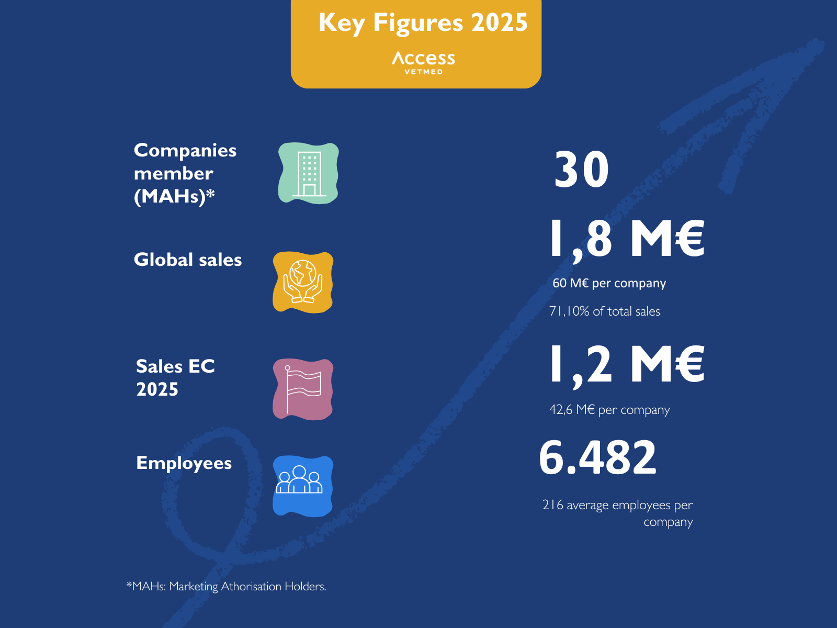

About Access VetMed
Access VetMed was founded in 2002 to act as the voice of the generic veterinary medicines industry in Europe. Today, it represents 30 generic and added-value veterinary medicines companies located across various European countries, including smaller markets. Together, its members generate a turnover of €1.8 billion and support more than 6,000 direct jobs, holding 52% of all generic veterinary medicines marketing authorisations in Europe.
The association actively and constructively engages with EU regulators and other stakeholders to promote transparent, harmonised, pragmatic and balanced animal health regulation. Its primary objective is to increase ACCESS —availability, compliance, convenience, efficacy, safety and savings— of veterinary medicines for veterinarians, farmers and companion animal owners across Europe.
More information: http://www.accessvetmed.eu

# # #

